CIMIC Meeting REPORT Example
Date of Release:

Routine | Priority | Immediate | Flash
Reference: None

GENERAL
MAIN TOPIC(S):
ACTOR(S):
NAME(S):
DTG MEETING:
GRID(S):

SUMMARY
BACKGROUND:
ATMOSPHERE:
SOURCE GRADING:
CONTENT: | 1.
ACTION(S)TO TAKE: | - TBD
NEXT MEETING: | - TBD

1 | Geography
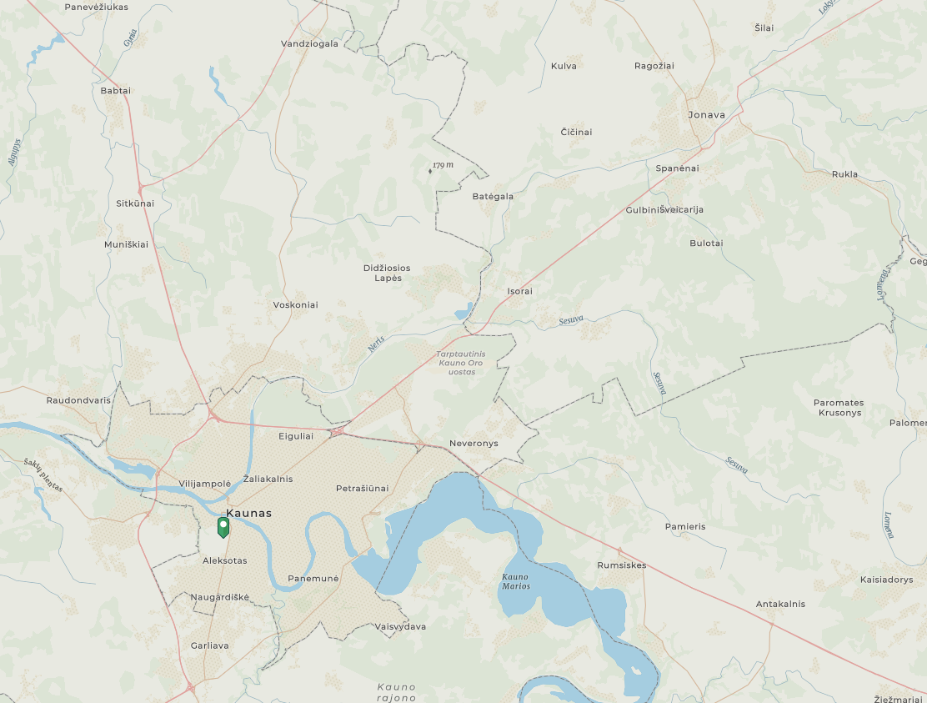
N
3
310525Cmay22 BwMaps // 34U FF 8531 8559

2
1
2 | Political
 | NTR
3 | Military /Security
 | NTR
4 | Economic
 | NTR
5 | Social
 | NTR
6 | Information
 | NTR
7 | Infrastructure
 | NTR
8 | ASSESSMENT
 | NTR
9 | CONCLUSION CIMIC
 | NTR

***END OF REPORT***

